ServiceNow Role-Based Project Management System

1. INTRODUCTION

1.1 Project Overview
This project implements a role-based project management system in ServiceNow using custom roles, Access Control Lists (ACLs), Flow Designer, notifications, and automation. It demonstrates secure access management and workflow automation for project lifecycle management.

1.2 Purpose
The purpose of this project is to develop a secure and efficient project management system using the ServiceNow platform. It implements role-based access control to ensure that Project Managers can create and manage projects, while Team Members can access only their assigned projects and update authorized fields. The project also leverages Flow Designer automation to streamline project assignment, notifications, and status tracking.

2. REQUIREMENT ANALYSIS

2.1 Problem Statement
Organizations require secure project management with controlled user access and automated workflows.

2.2 Objectives
Implement custom users, roles, ACLs, notifications, and automated flows for assignment and completion.

2.3 Technology Stack
ServiceNow Platform, ACLs, Work Flow Studio, Notifications, Number Maintenance.

3. PROJECT DESIGN

3.1 Solution Architecture
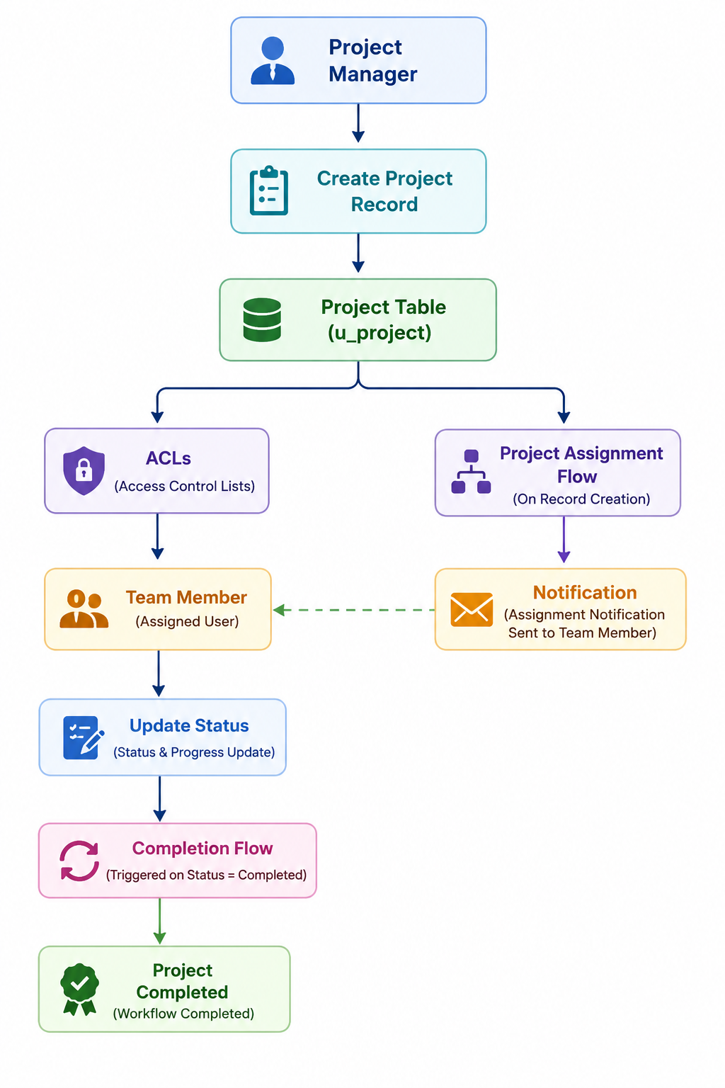

3.2 User Roles

1.Project Manager

The Project Manager is responsible for creating, managing, assigning, and monitoring project records. This role has full access to perform Create, Read, Update, and Delete (CRUD) operations on project records and can assign projects to Team Members for execution.

2.Team Member

The Team Member is responsible for executing assigned projects. This role has restricted access and can view only the projects assigned to them. Team Members are authorized to update only the Status and Progress Update fields, ensuring secure and controlled project management through Access Control Lists (ACLs).

3.3 Database Design
The application uses a custom Project (u_project) table to store and manage project-related information. The table extends the Task table to leverage ServiceNow's built-in task management capabilities while supporting project-specific configurations.
The primary fields in the Project table include:
Field | Description
- Project ID | Unique identifier generated using custom Number Maintenance (PRO0001, PRO0002, ...).
- Assigned To | Specifies the Team Member responsible for the project.
- Short Description | Provides a concise summary of the project.
- Description | Contains detailed information about the project requirements.
- Status | Indicates the project's priority level (Low, Moderate, High, Critical).
- Priority | Represents the current stage of the project (Open, Work in Progress, Completed, etc.).
- Work Update | Stores the latest progress or completion remarks entered by the Team Member or automated through Flow Designer.

4. IMPLEMENTATION
👤 Users
Alice User Configuration
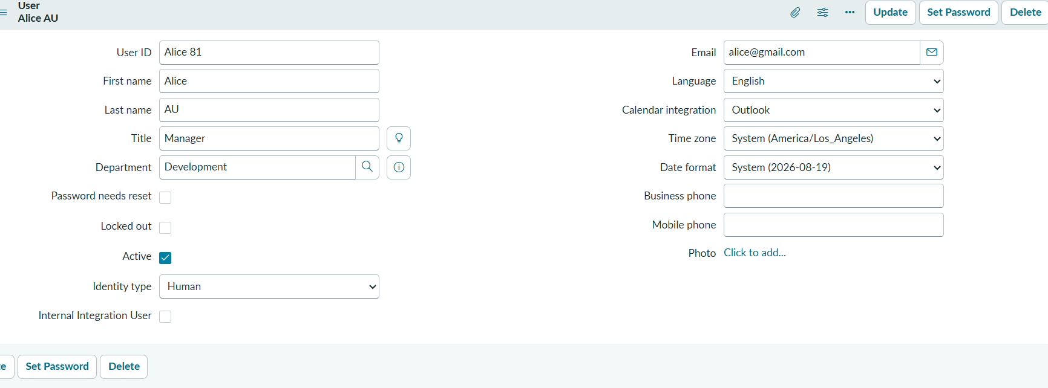
Bob User Configuration
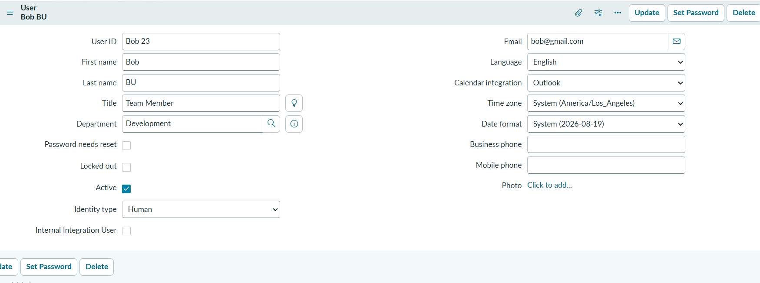
🔑 Roles
Project Manager Role
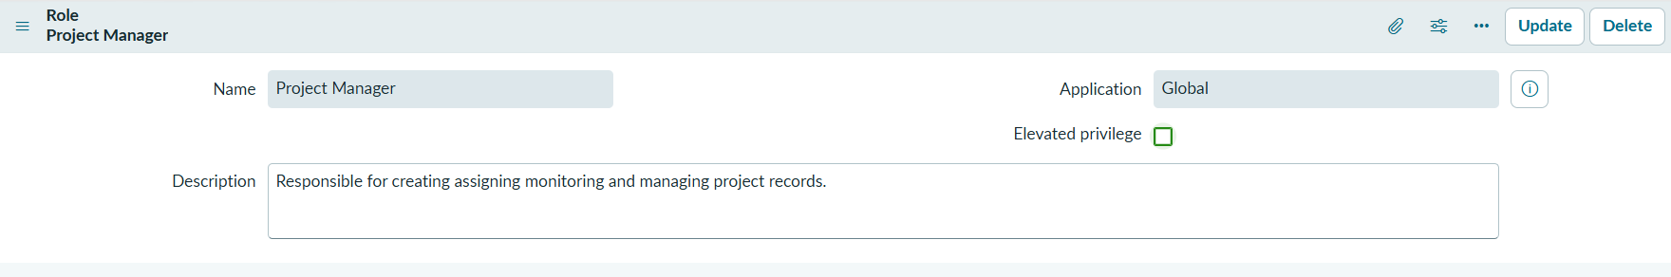

Team Member
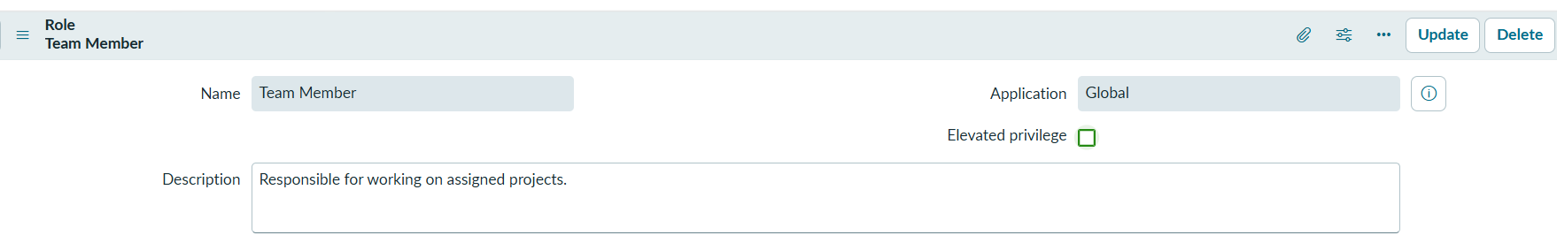
📂 Project Table
Project Table Configuration
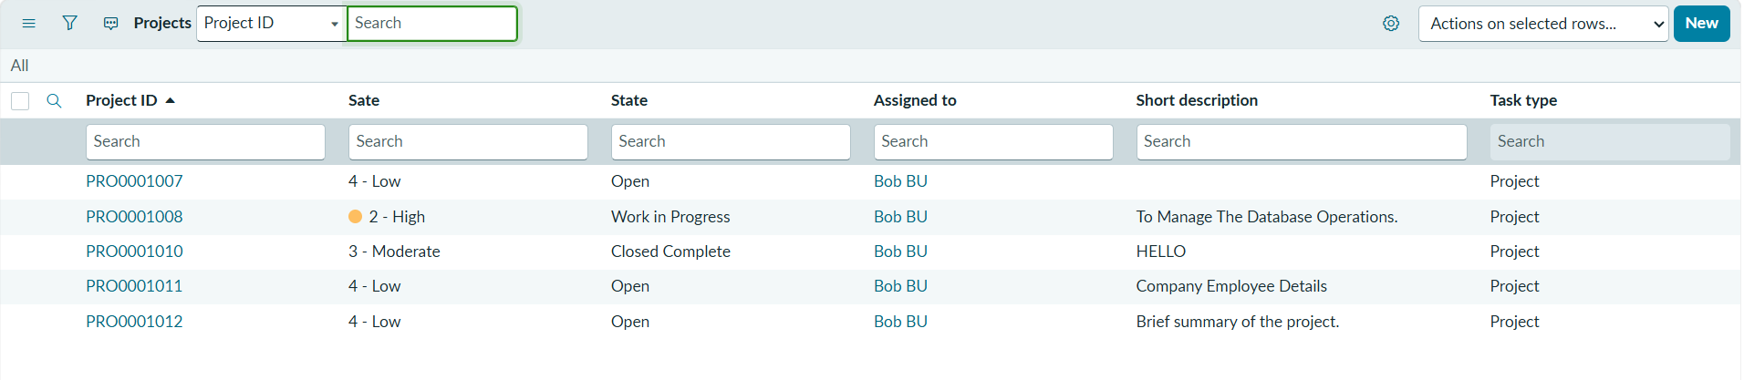
Project Form Layout
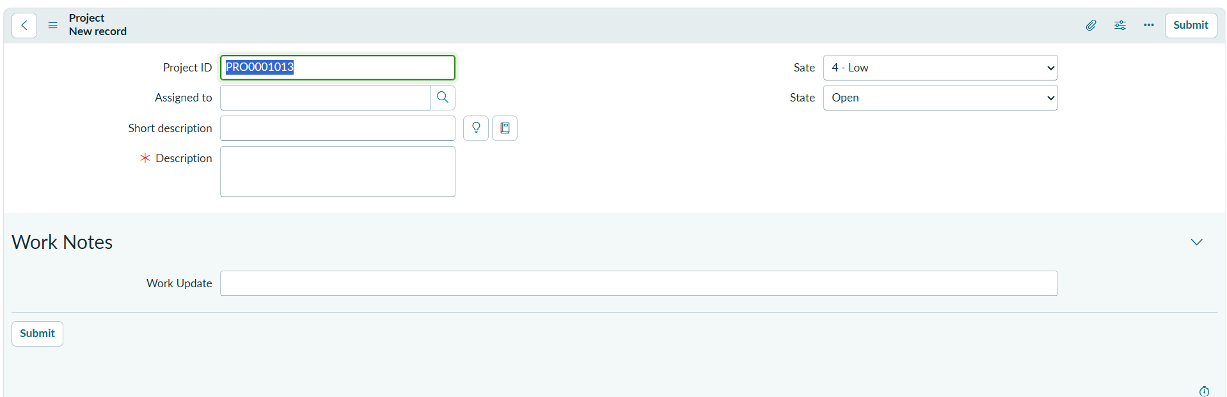

Number Maintenance Configuration
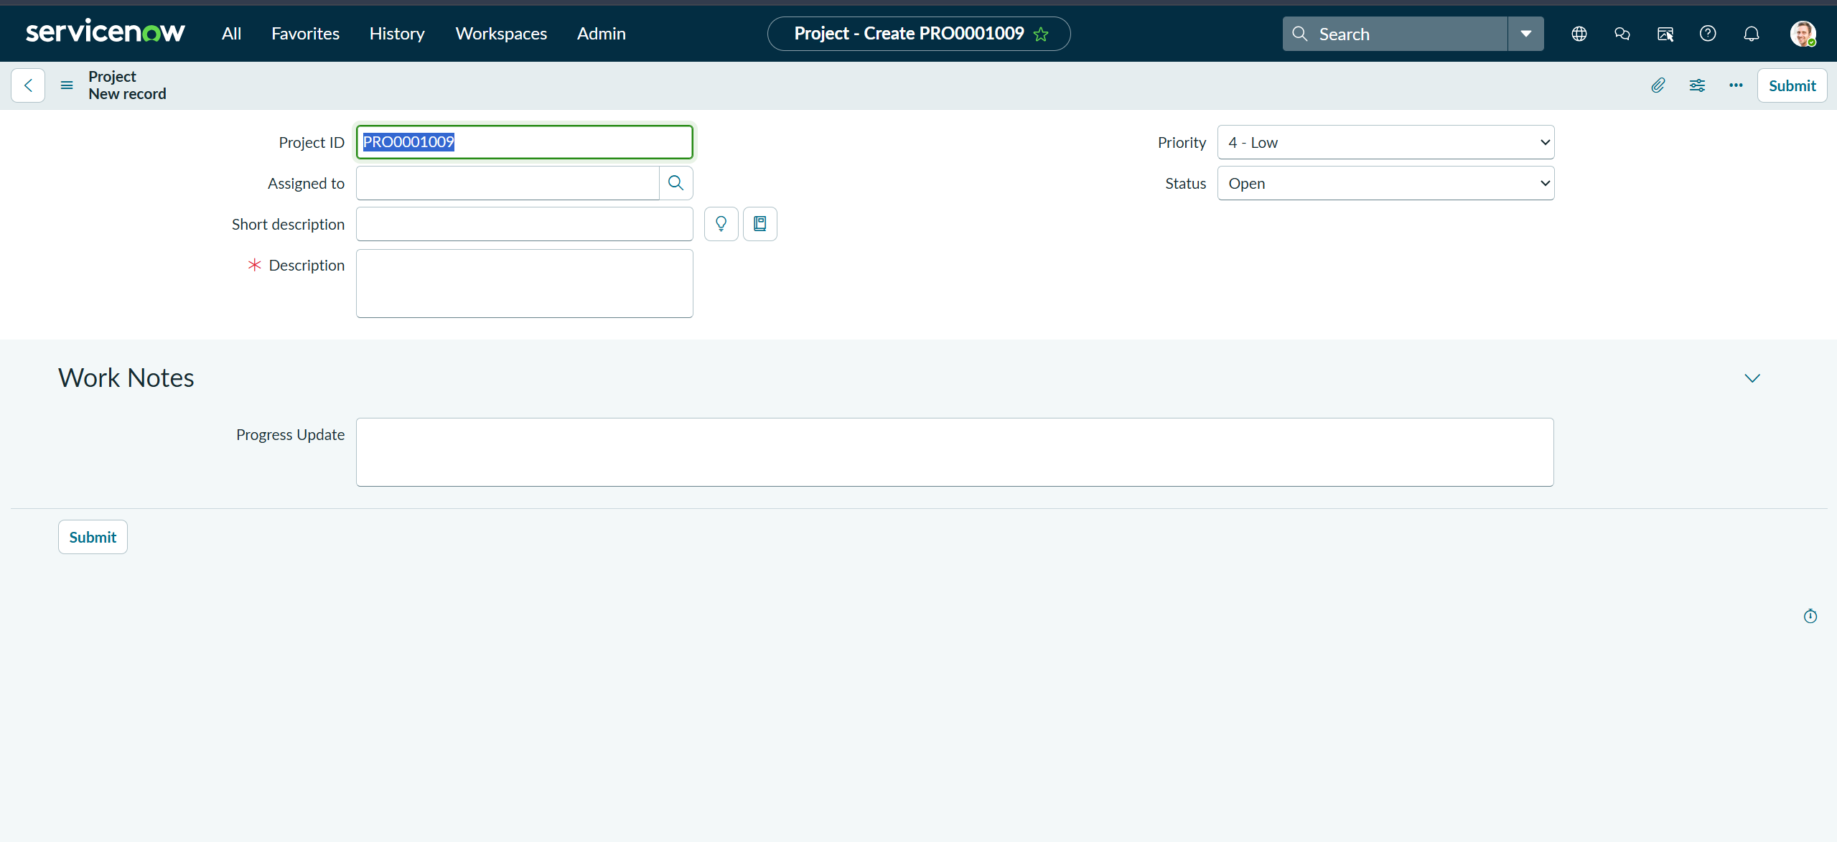
🔒 Access Control Lists (ACLs)
Create ACL
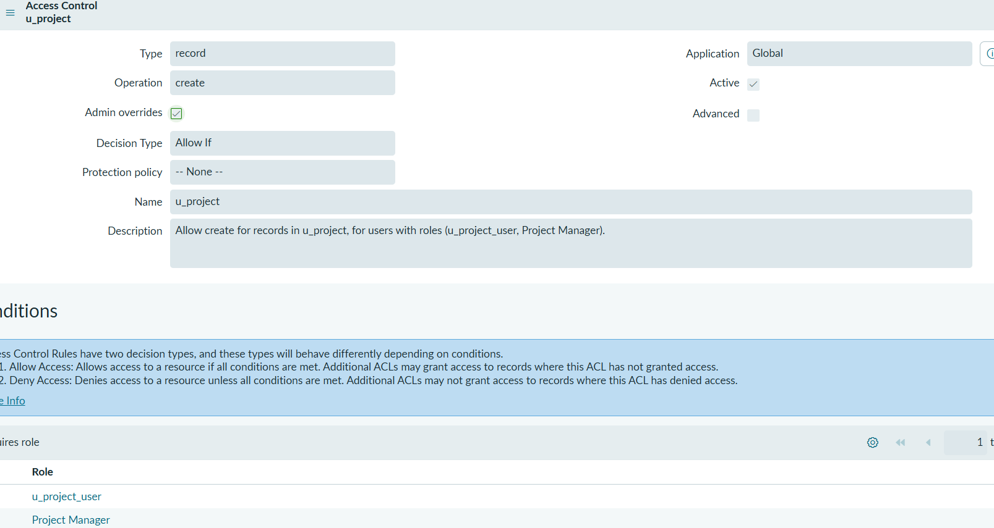

Read ACL
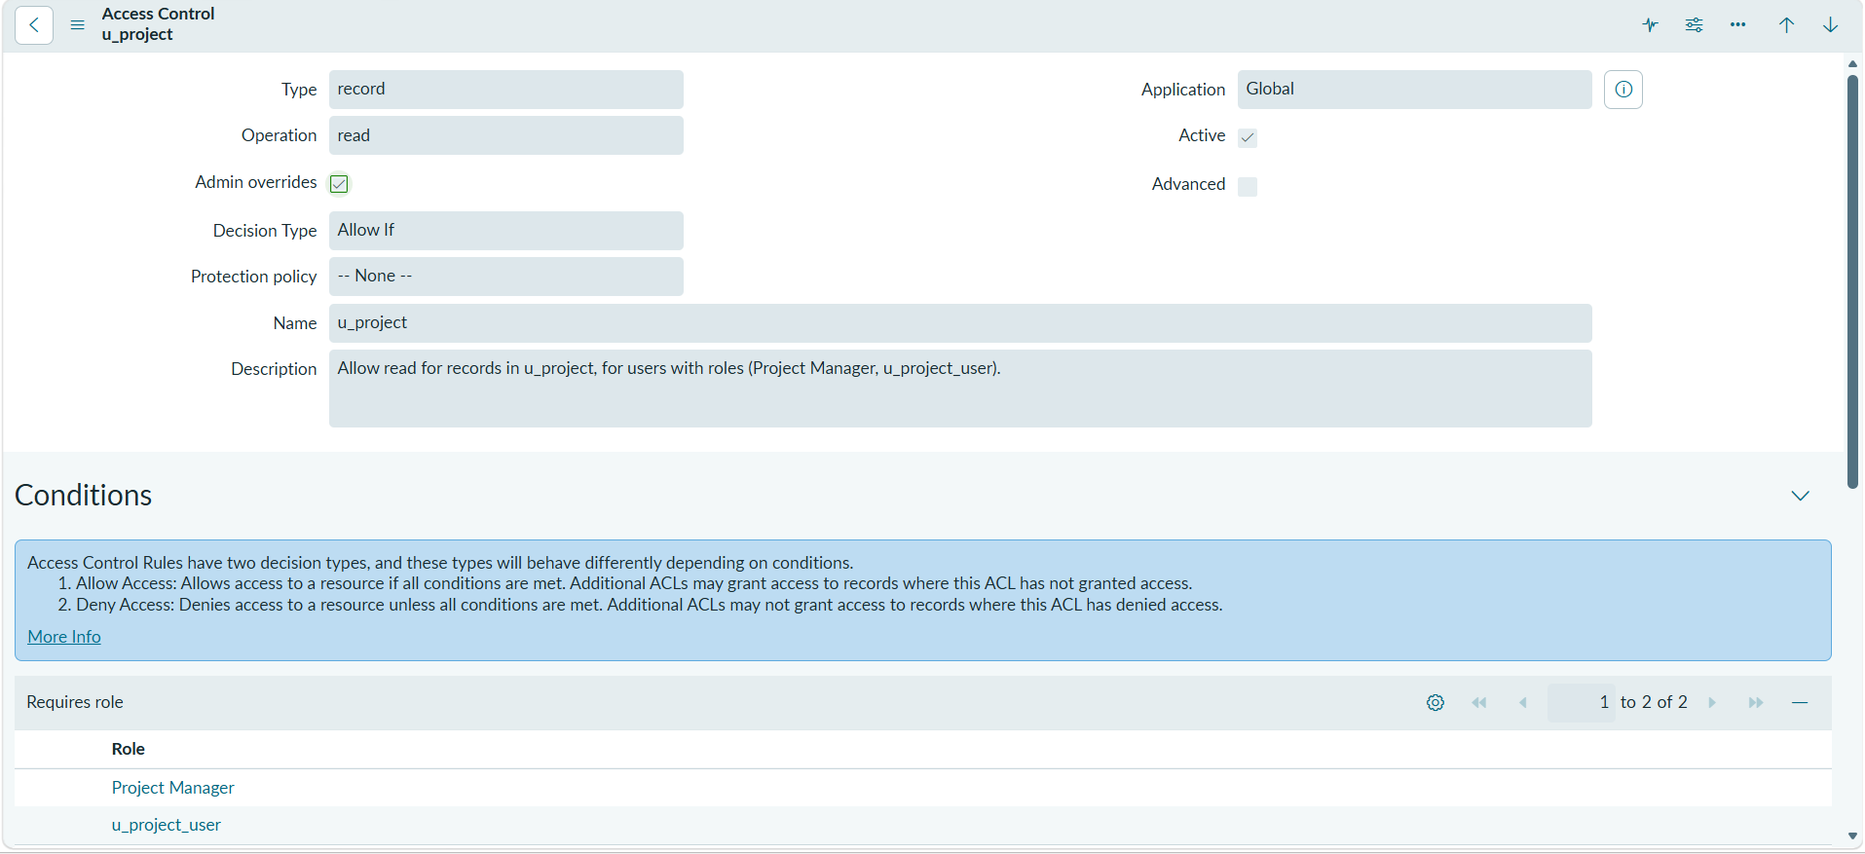
Write ACL
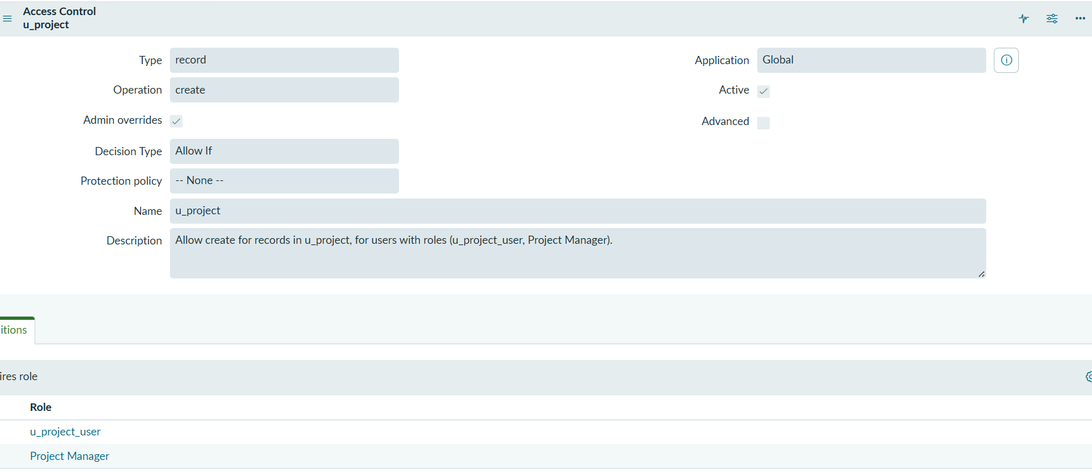

Delete ACL
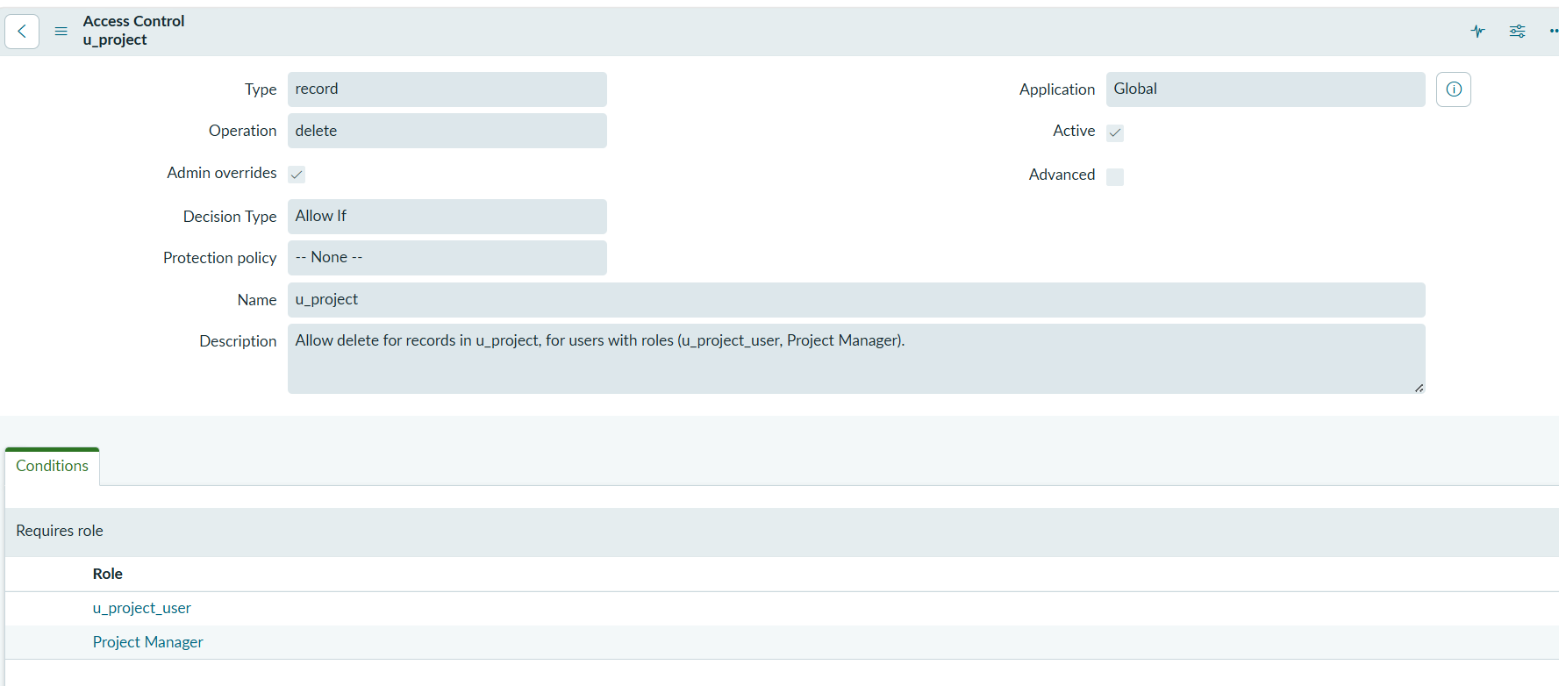
Team Member Read ACL
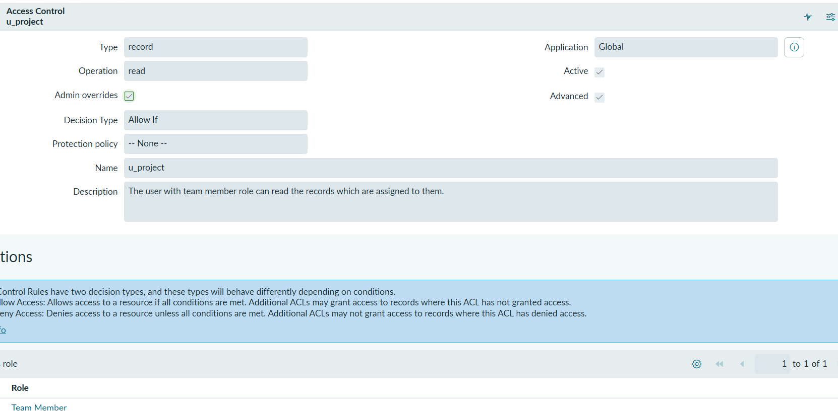
State Field ACL
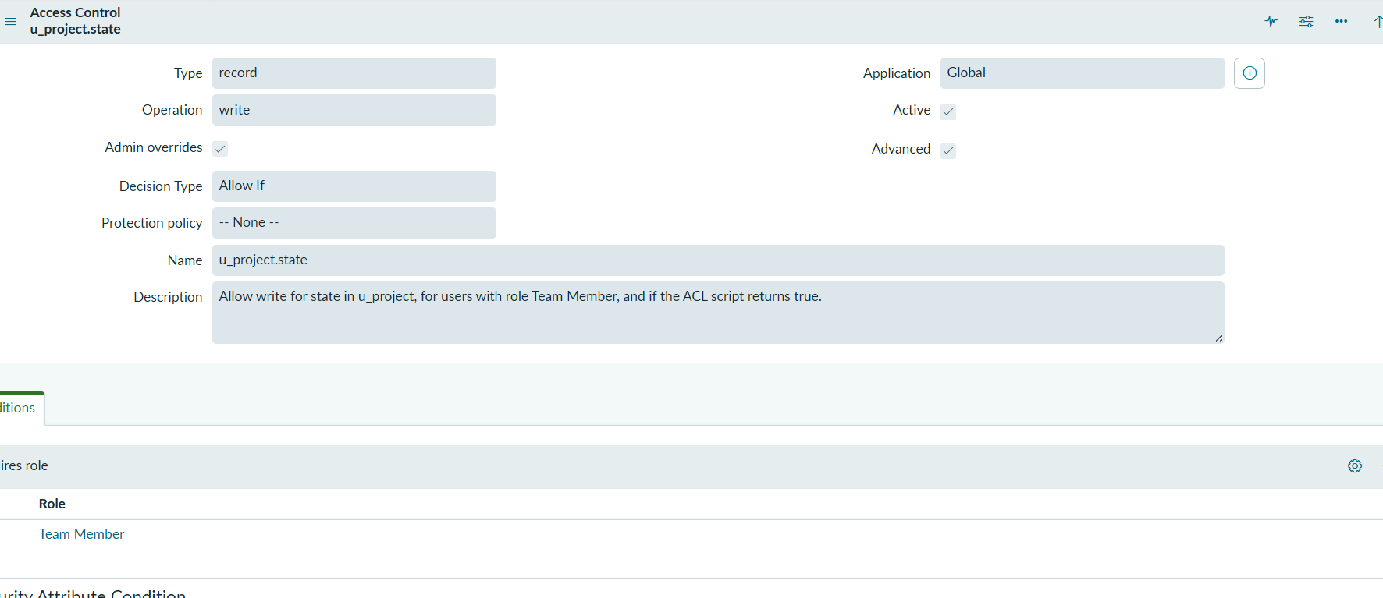
Progress Update Field ACL
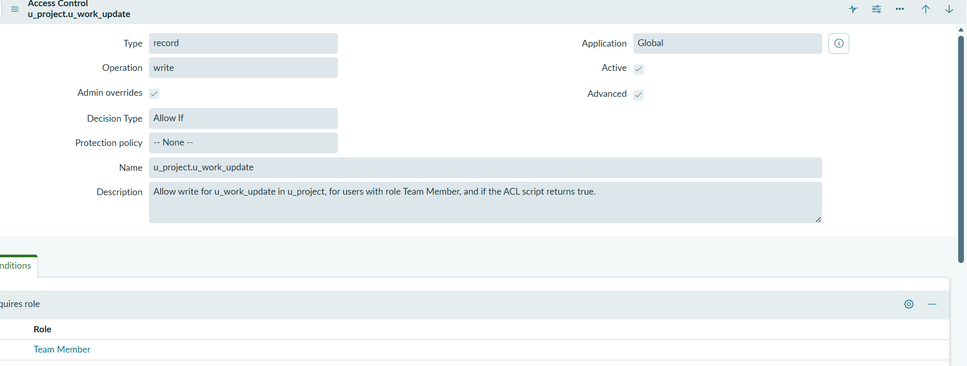
📧 Notifications
Project Assignment Notification
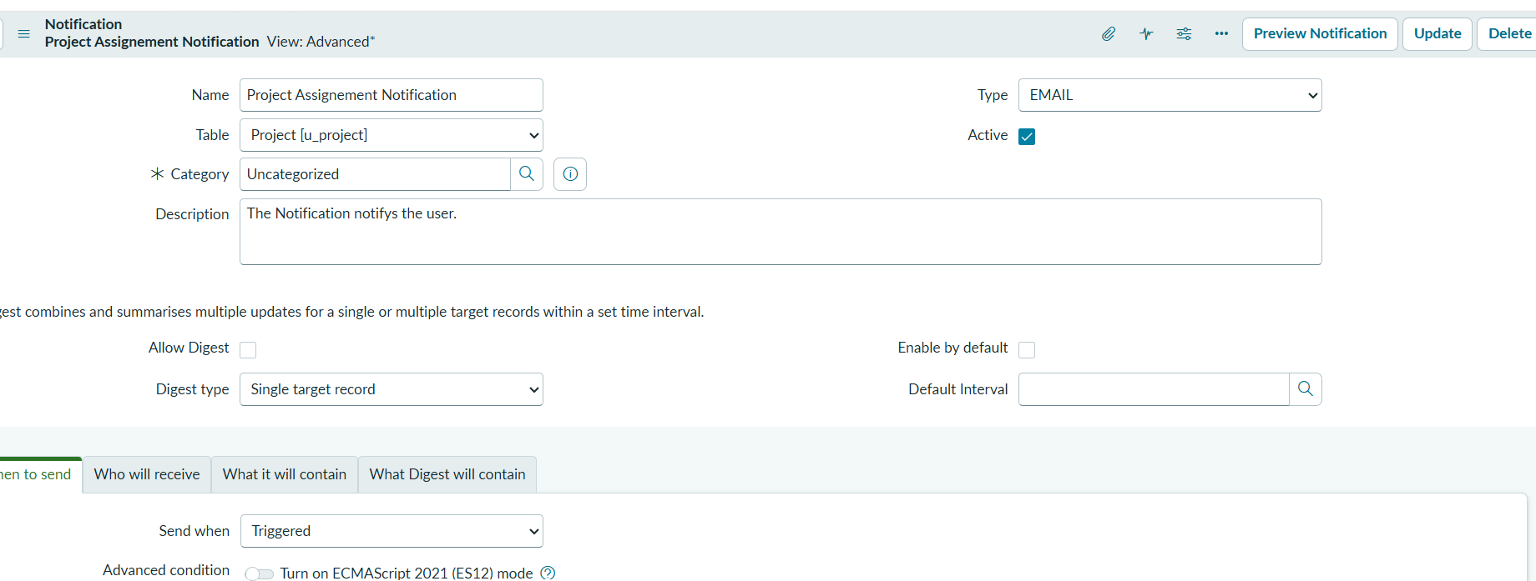
Notification Content
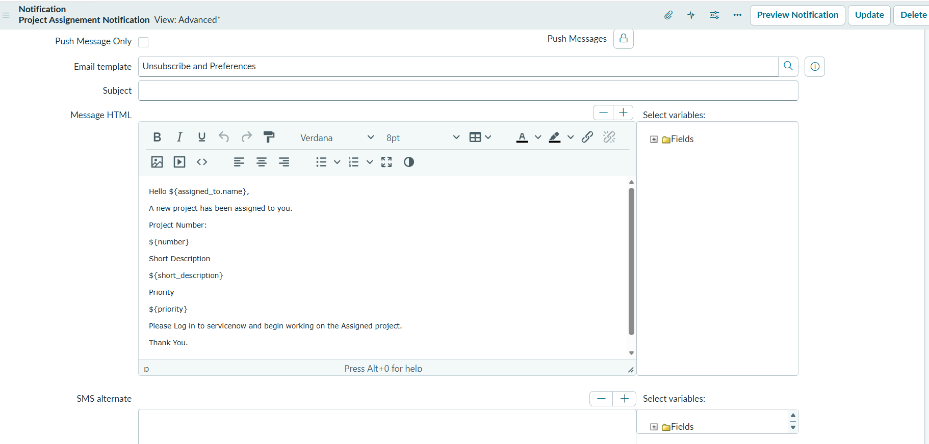
Notification Recipients
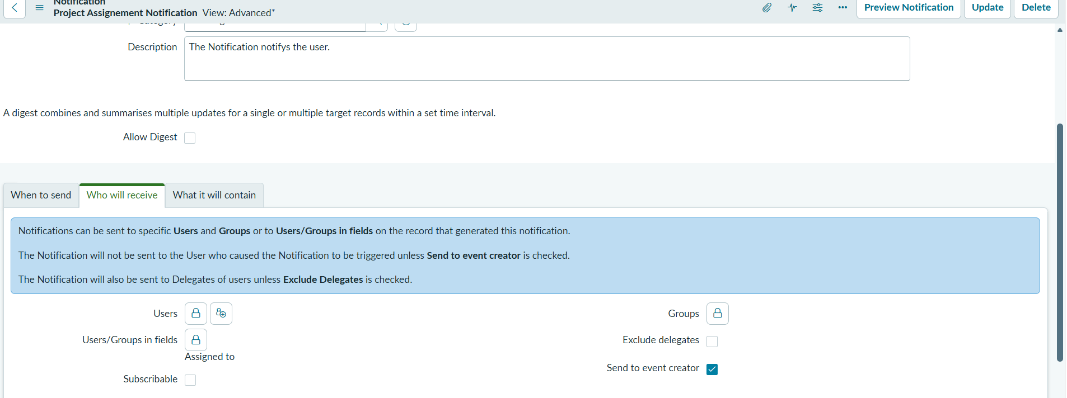
🔄 Flow Designer
Project Assignment Flow
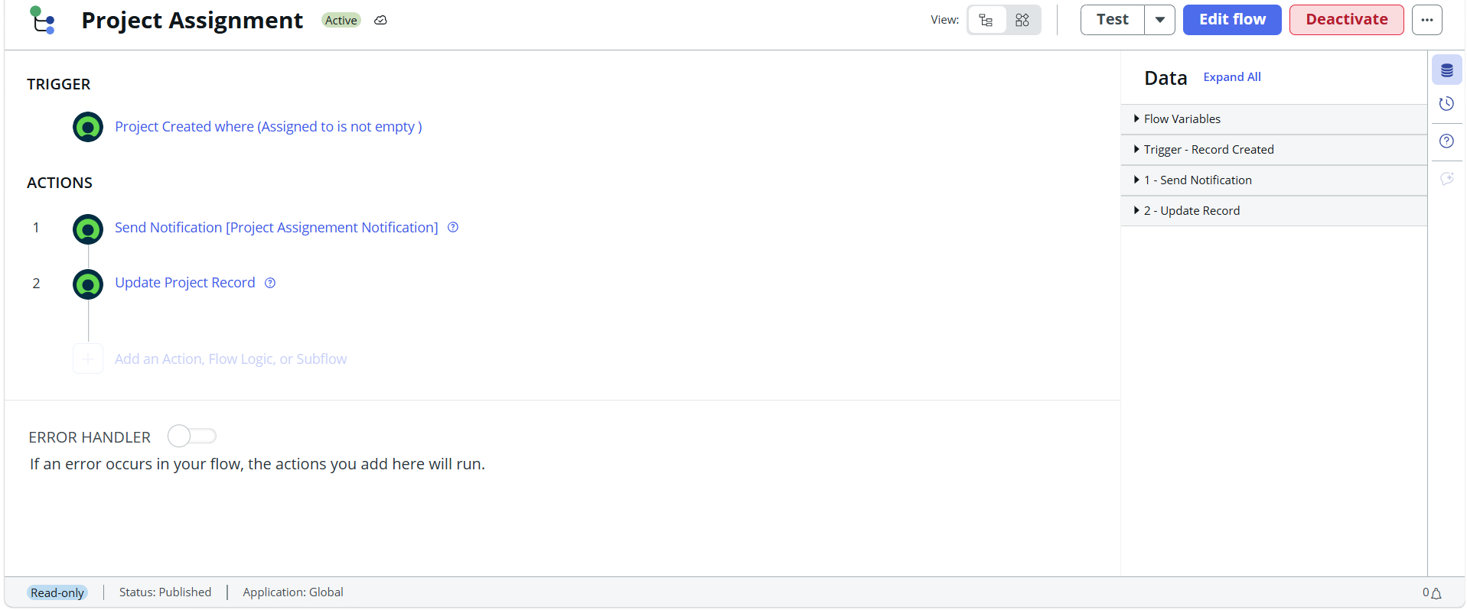
Project Completion Flow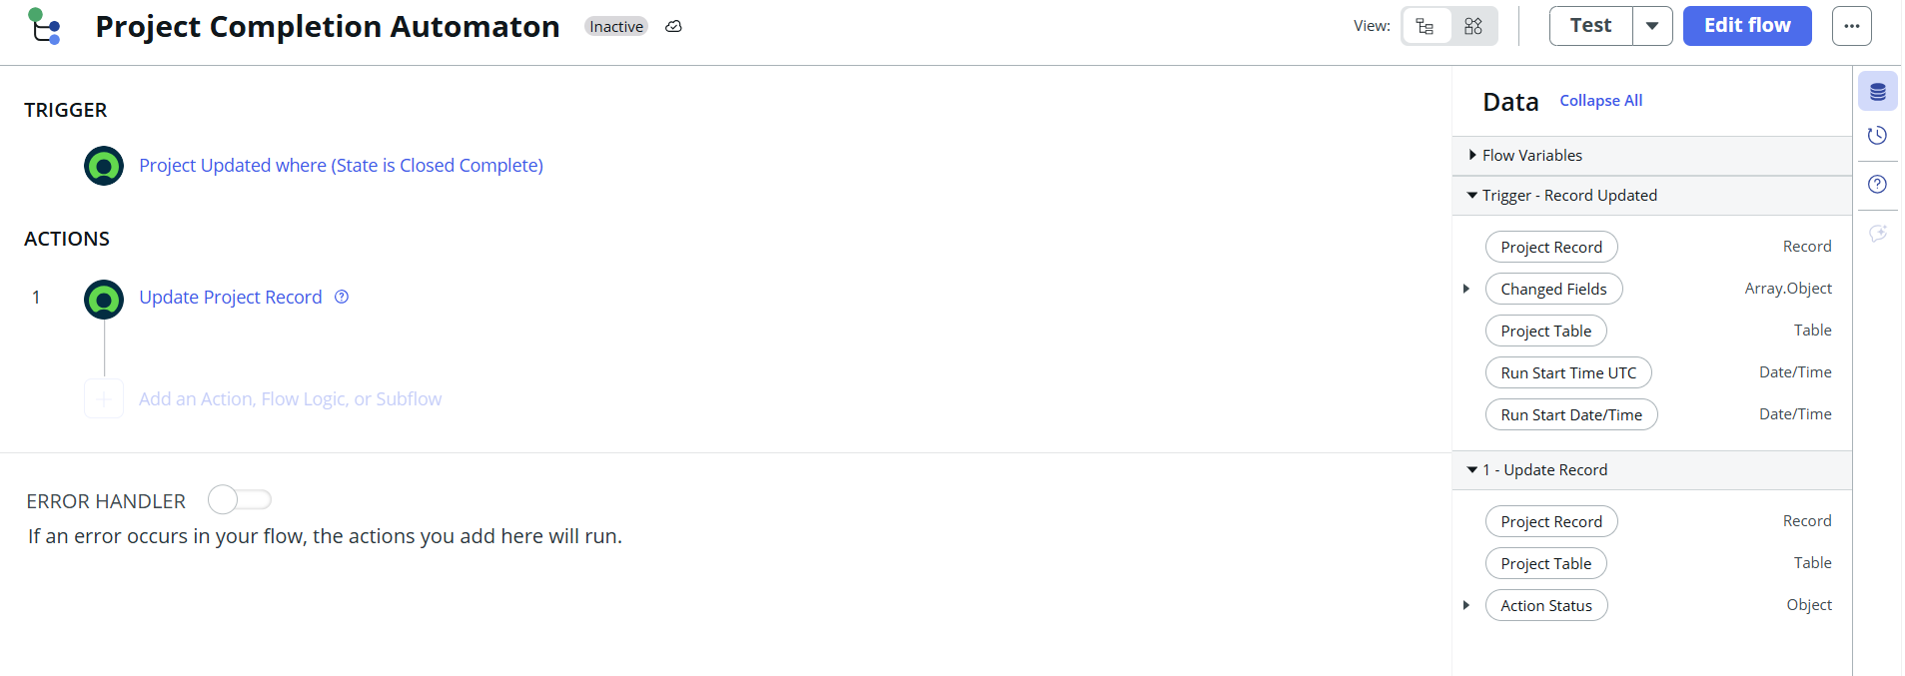
🧪 Testing
Alice - List View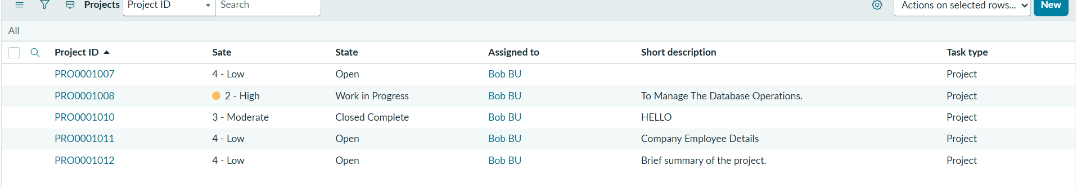
Alice - Form View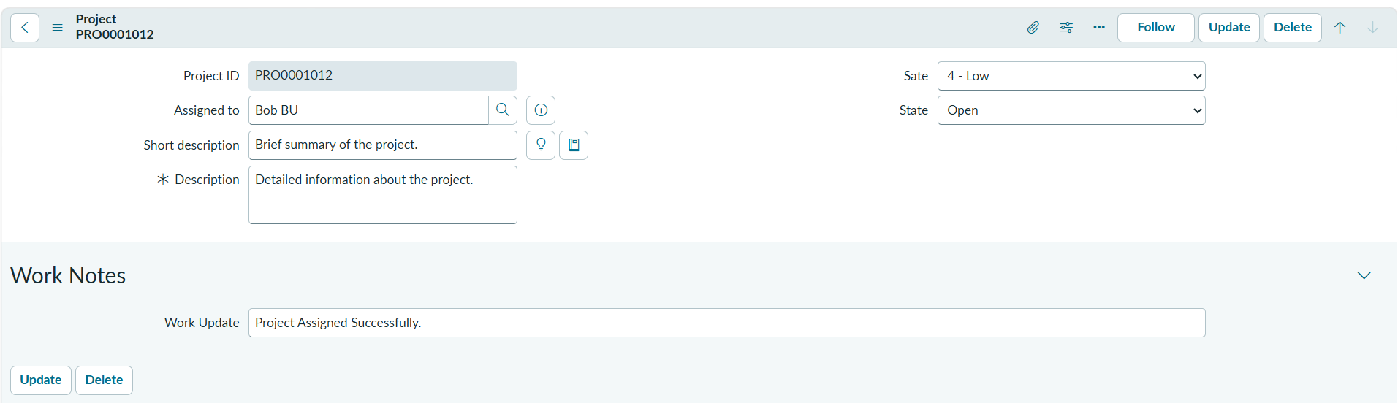
Bob - List View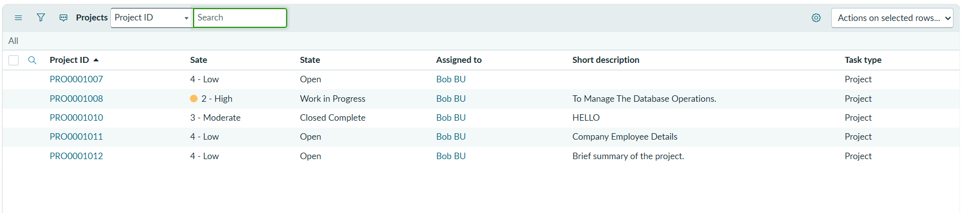
Bob - Form View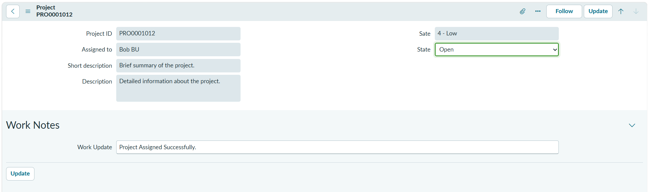
✅ Final Outputs
Project Assignment Flow Execution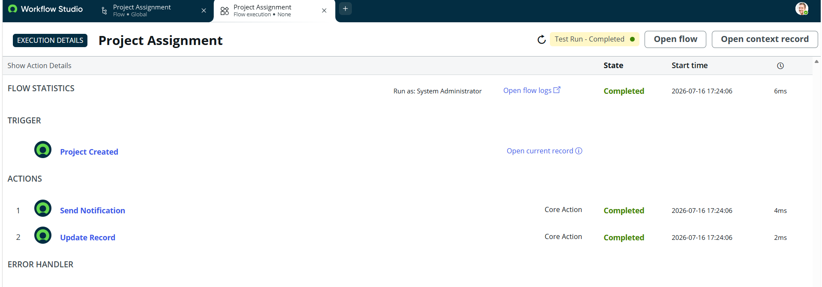
Project Assignment Flow Actions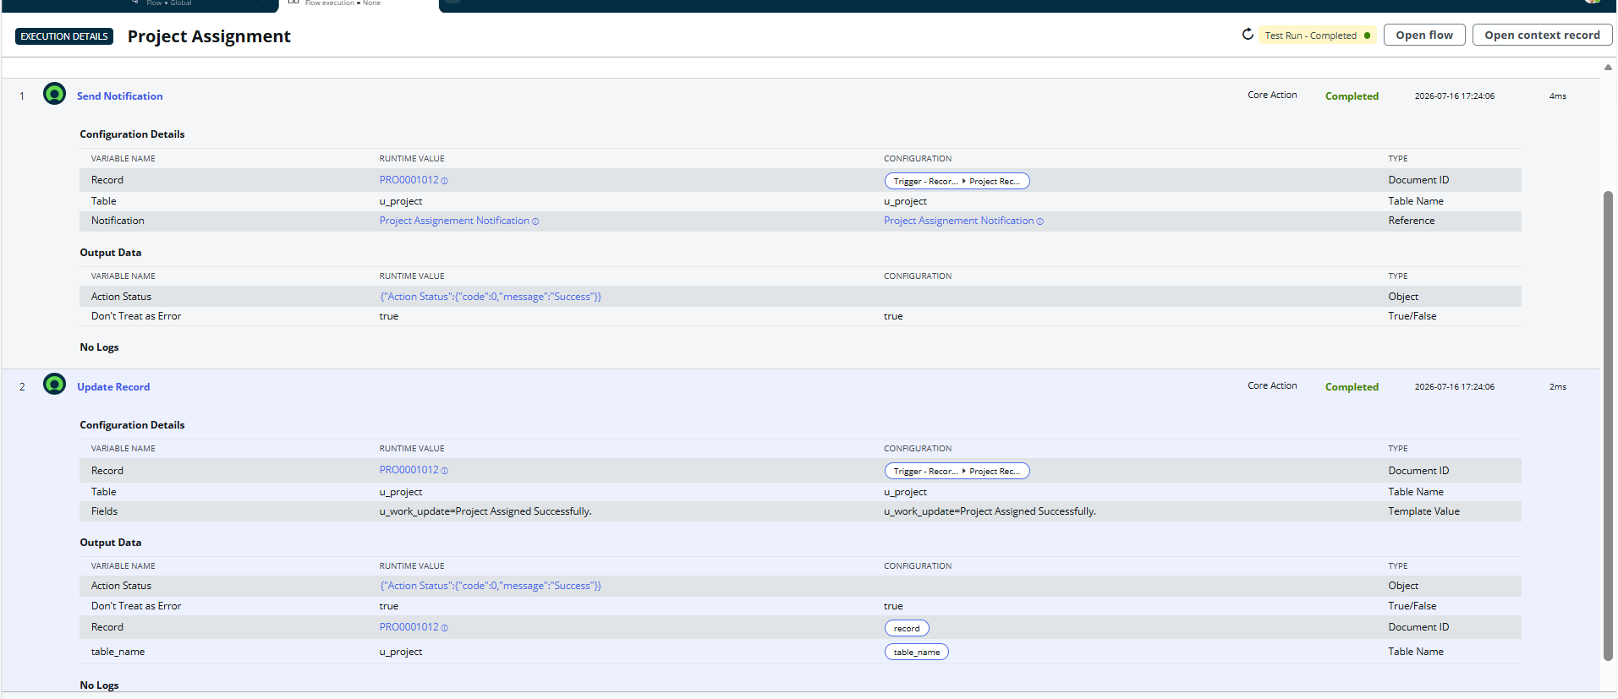
Project Completion Flow Execution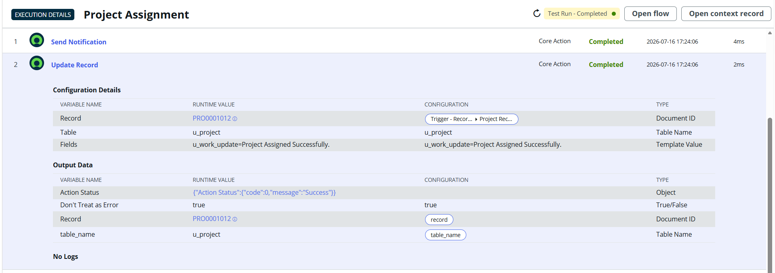
Completed Project Record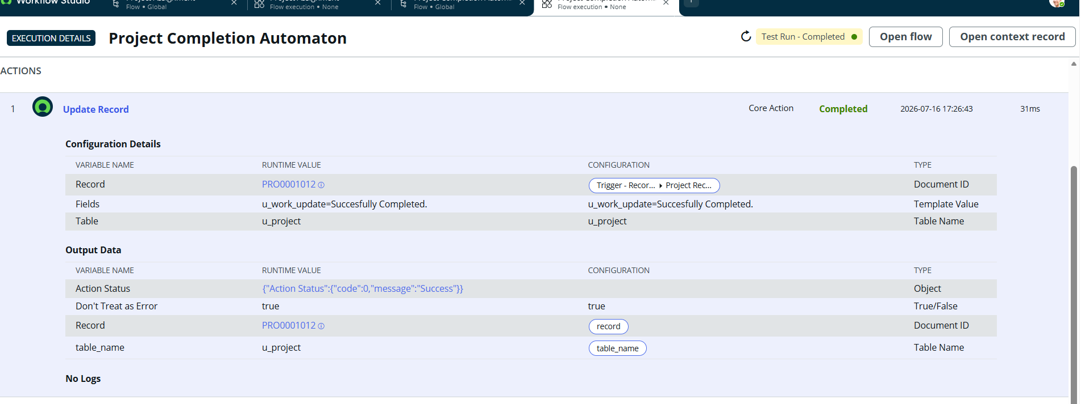

7.ADVANTAGES
i. Enhanced Security
Implements role-based access control using Access Control Lists (ACLs), ensuring users can access only the records and fields authorized for their roles.
ii. Improved Process Automation
Automates project assignment notifications and project completion updates using Flow Designer, reducing manual effort and improving workflow efficiency.
iii. Better Project Management
Provides a centralized platform for creating, assigning, tracking, and managing projects, enabling better collaboration, accountability, and progress monitoring among team members.
8. CONCLUSION
The project successfully demonstrates how ServiceNow can be used to build a secure role-based project management application using ACLs, Flow Designer, notifications, and automation.

9. FUTURE SCOPE
•Dashboard integration
• SLA management
• Approval workflows
• Reporting and Analytics

10. APPENDIX
GitHub Repository : Click Here For Git Repository.
Project Demo Video : Click Here For Demo Video.
Update Set: Included

